

2

2026–2027 Enrollment Packet

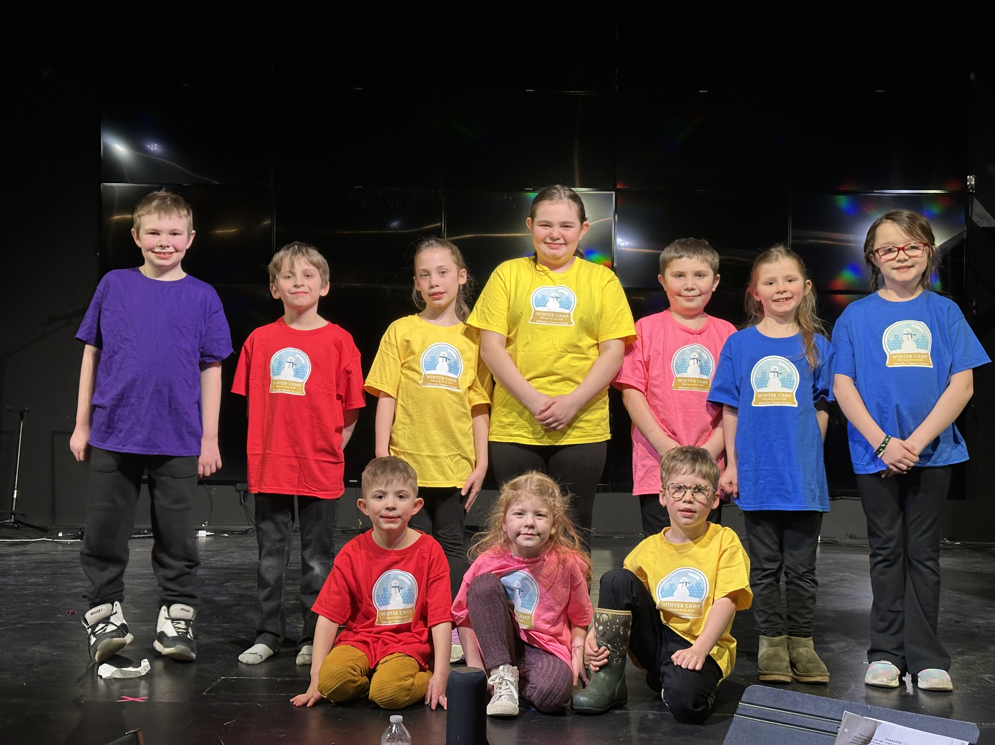

Welcome Letter

Dear Returning and Prospective S.A.I.L. Family,
Thank you for choosing Strategic Academy of Innovative Learning. We are committed to providing a safe, nurturing, and individualized learning environment where every child is encouraged to learn at their own pace and reach their fullest potential.
We look forward to partnering with your family throughout the school year.
Sincerely,
Sharon Arsenault
Head of School

Mission Statement

Our mission is to provide a safe alternative to public school, while allowing students to work at their own level and at their own pace, so that they become empowered, lifelong learners.

Vision
Every child succeeds through personalized learning, strong family partnerships, and a supportive school community.

Why Choose S.A.I.L.?
• Small class sizes
• Individualized instruction
• Students work at their own pace
• Caring teachers
• Safe learning environment
• We accept EFA scholarships
• Flexible payment plans
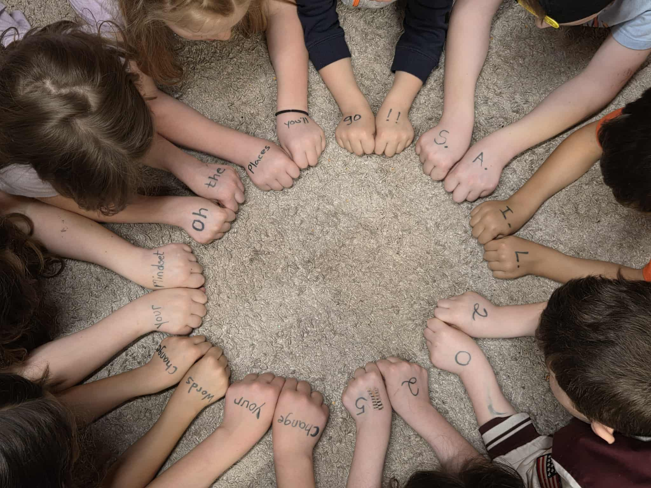
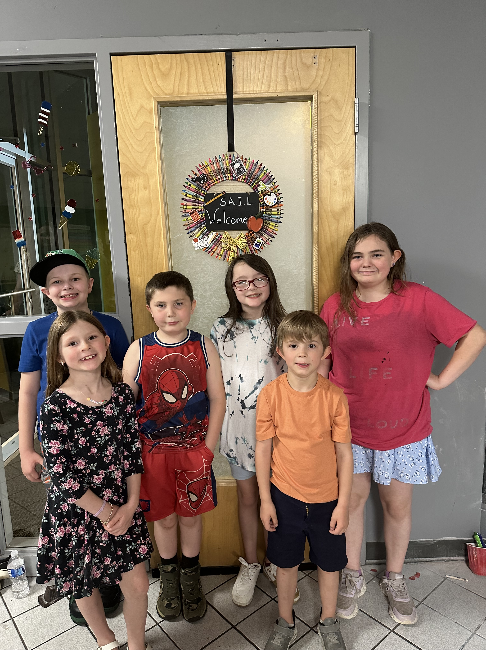
.

Student Registration

Student Name: _____________________________________________________________________________________
Preferred Name: ___________________________________________________________________________________
Date of Birth: ___________________________________
Entering Grade: Pre-K4 / K / 1 / 2 / 3 / 4 / 5 / 6 / 7 / 8 / 9
Address: _____________________________________________________________________________________________
City/State/Zip: __________________________________ State_________ zip__________
Previous School: ____________________________________________________________________________________
Parent(s) names _____________________________________ _ _____________________________________________
Parent Telephone_____________________________________ ______________________________________________
Mom Dad
Who can pick up my child (ID will be required)
______________________________________. _________________________________________ _______________________
Name Phone Relationship
______________________________________. _________________________________________ _______________________
Name Phone Relationship
Is there anyone not allowed to pick up your child? Yes No. (if yes, list name)
Does your child have any allergies? Yes No (if yes, please list on back of sheet)

Enrollment Checklist
☐ Registration Form
☐ Birth Certificate
☐ Immunization Records
☐ Proof of Residency
☐ Emergency Contacts
☐ Medical Forms
☐ Records Release
☐ Tuition Agreement

Student Medical Release & Emergency Authorization Form
School Year: ______________________

Student Information
Student Name: ___________________________________________
Date of Birth: ___________________ Grade: ___________
Parent/Guardian Name(s): __________________________________
Home Address: ____________________________________________

Primary Phone: _____________________
Secondary Phone: __________________
Email: _________________________________________________

Emergency Contacts
1. Name: ________________________________________________
Relationship: ____________________
Phone: _________________________________________________
2. Name: ________________________________________________
Relationship: ____________________
Phone: _________________________________________________

Medical Information
Primary Physician: _______________________________________
Physician Phone: _________________________________________
Preferred Hospital: ______________________________________
Health Insurance Company: ________________________________
Policy Number (Optional): ________________________________

Medical Conditions
Please check all that apply:
☐ Asthma
☐ Diabetes
☐ Seizure Disorder
☐ Heart Condition
☐ Severe Allergies
☐ Food Allergies
☐ Bee/Insect Sting Allergy
☐ Medication Allergy
☐ Other: _________________________________________________
Please explain any medical conditions or special health concerns:

Emergency Medical Authorization
In the event that I cannot be reached, I authorize Strategic Academy of Innovative Learning (S.A.I.L.) to obtain emergency medical treatment for my child if school
personnel determine that immediate medical care is necessary. I understand every reasonable effort will be made to contact me before treatment is provided.
I authorize licensed physicians, emergency medical personnel, and hospitals to provide treatment deemed necessary for my child.
______________________________________________________________- _______________________________
Signature of parent Date

Strategic Academy of Innovative Learning (S.A.I.L.)

Photography, Video & Image Release Form
School Year: ______________________

Student Information
Student Name: ___________________________________________
Date of Birth: ___________________ Grade: ___________
Parent/Guardian Name: ____________________________________
Phone: _________________________________________________
Email: _________________________________________________

Permission to Use Student Images
Throughout the school year, Strategic Academy of Innovative Learning (S.A.I.L.) may photograph, videotape, or record students participating in educational activities, performances, field trips, athletic events, classroom projects, and other school-sponsored programs.
These images and recordings may be used for educational, informational, or promotional purposes, including but not limited to:
☐ School website
☐ School social media pages
☐ Printed brochures and marketing materials
☐ Newsletters
☐ School yearbook
☐ Local newspapers or television coverage
☐ Classroom presentations
☐ School displays and bulletin boards
☐ Other school publications
I understand that photographs, videos, and recordings may be used by Strategic Academy of Innovative Learning (S.A.I.L.) without compensation.
I understand that my child's name will not be published with photographs unless I provide separate written permission or disclosure is required by law.
I understand that once images are published online or shared through media outlets, the school cannot control how they may be viewed or shared by others.
This authorization remains in effect for the current school year unless revoked in writing.

Please select one:
☐ YES — I give permission for Strategic Academy of Innovative Learning (S.A.I.L.) to photograph and/or video my child and use these images for school-related educational and promotional purposes.
☐ NO — I do not give permission for Strategic Academy of Innovative Learning (S.A.I.L.) to photograph or video my child for publication or promotional purposes.
I certify that I am the parent or legal guardian of the student listed above and have the authority to grant or deny this permission.
Parent/Guardian Name (Print):

Signature:

Date: ______________________

☐ School Yearbook
☐ Local newspapers or television coverage
☐ Classroom presentations
☐ School displays and bulletin boards
☐ Other school publications

Parent/Guardian Authorization
I understand that photographs, videos, and recordings may be used by Strategic Academy of Innovative Learning (S.A.I.L.) without compensation.
I understand that my child's name will not be published with photographs unless I provide separate written permission or disclosure is required by law.
I understand that once images are published online or shared through media outlets, the school cannot control how they may be viewed or shared by others.
This authorization remains in effect for the current school year unless revoked in writing.

Please select one:
☐ YES — I give permission for Strategic Academy of Innovative Learning (S.A.I.L.) to photograph and/or video my child and use these images for school-related educational and promotional purposes.
☐ NO — I do not give permission for Strategic Academy of Innovative Learning (S.A.I.L.) to photograph or video my child for publication or promotional purposes.

Parent/Guardian Signature
I certify that I am the parent or legal guardian of the student listed above and have the authority to grant or deny this permission.

Signature:

Date: ______________________

Parent/Guardian Information

Parent/Guardian 1: _______________________________________________________________________________________________
Relationship: ________________________________________________________________________________
Phone: _______________________________________________________________________________________
Email: _______________________________________________________________________________________
Parent/Guardian 2: _________________________________________________________________________
Relationship: _________________________________________________________________________________
Phone: ________________________________________________________________________________________
Email: __________________

Emergency Contacts
1. ______________________________________
Relationship __________ Phone __________
2. ______________________________________
Relationship __________ Phone __________
3. ______________________________________
Relationship __________ Phone __________

Authorized Pick-Up
Authorized Adults:
1. ___________________________
2. ___________________________
3. ___________________________
The following individuals are NOT authorized to pick up my child:
__________________________________________

